Year 7

Term 1 Test

Section 2 - Resources Allowed

Name: ______________________ Class: ______ Time: 40 minutes Total Mark:____/42

Show working and answers on this sheet. Show working in sufficient detail to support your answers. Incorrect answers without supporting reasoning may be allocated zero marks.

Calculator Allowed

Question 1 2 marks

  - Write four-fifths as a fraction: _____________________________________

  - Write the following 6 $\frac{1}{2}$ as words: ________________________________


Question 2 2 marks

What fraction is the shaded part of the whole:

i) ii)

Question 3 2 marks

  - What fraction is 25c of $2? _____________________

  - What fraction is 75c of $1? ___________________

Question 4 2 marks

    - Change 2 $\frac{3}{4}$ to an improper fraction: __________________________

    - Change $\frac{13}{5}$ to a mixed number: ____________________________

Question 5 2 marks

Calculate each of the following:

  - $\frac{3}{4}$ of 12: _____________________

  - 25% of 20: ___________________

Question 6 5 marks

Calculate the area of the following shapes:

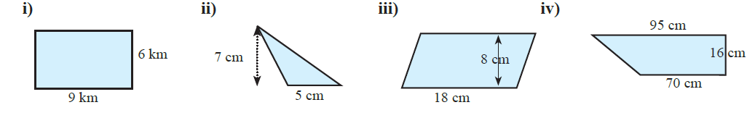

Question 7 2 marks
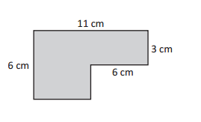
Find the perimeter of this shape.

Question 8 2 marks

What is the area of a bedroom wall that is 3.4m wide by 2.4m high? Roughly how much paint is needed for two coats of paint for the wall (A litre of paint will cover 15m² on average)?

Question 9 2 marks

A rectangular paddock is 850m by 420m. What is the area of the paddock in hectares (1 hectare = 10,000m² )?

Question 10 3 marks

When tossing a coin the theoretical probabilities are:
Probability of a head = 1/2 = 0.5 Probability of a tail = 1/2 = 0.5

  - If a coin is tossed 80 times, how many heads would be expected?

  - A coin is tossed 80 times, how many tails would be expected?

  - If a coin is tossed 800 times, how many heads would be expected?

Question 11 3 marks

A class raffle is conducted by writing the numbers from 1 to 30 on a piece of paper and placed in a bag. What is the probability that the drawn number is:

  - 15? ______________________________

  - even? ______________________________

  - divisible by 3? ______________________________

Question 12 3 marks

A lottery is conducted by printing and selling tickets with the numbers from 1 to 100,000.

  - What is the probability that the drawn number is 43 546?

  - If you purchase one ticket, what is your chance of winning?

  - If you purchase 10 tickets, what is your chance of winning?

Question 13 2 marks

Add GST (10%) to the price of each of the following items:

  - A hamburger @ $7 ii) A shirt @ $19.00

Question 14 2 marks

A discount of 20% is offered on each of the following items. Find the discount, and the new price:

  - A pen @ $4 ii) A saxophone @ $980

Question 15 2 marks

If the price of unleaded petrol is $2.14 per litre:

i) What is the cost of 65 L of petrol?

ii) How much petrol can be bought with $20?

Question 16 4 marks

Find the rate for a 100 of each of the following:

  - $45 for 300g ii) $5.48 for 800g

iii) $8.12 for 700mL iv) $6.20 for 500 mins

Question 17 2 marks

Which is the best buy?

  - $6.40 for 500mL of soy sauce or $9.80 for 800mL?

  - $2.48 for 400g of milk powder or $3.84 for 600g?

END OF TEST
Year 7

Term 1 Test

Section 1 - No Resources allowed

Name: ______________________ Class: ______ Time: 10 minutes Total Mark:____/10

Answer all questions. Each question is worth one mark.

- Add GST (10%) to $40:

- $2.50 per litre. How much for 6 litres?

- A coin is tossed. What is the chance of tails?

- A 6-sided dies is tossed, what is P(>4)?

- What is the formula for the area of a rectangle?

- What is the formula for the area of a triangle?

- What is the area of a triangle 6cm by 3cm?

- Change 40% to a fraction:

- Which is the best buy: $8 for 4 L or $12 for 3 L?

- If the price of petrol is $2 per litre, how much for 50 L?

[10 marks]



